Ideation Phase
Define the Problem Statements

Date | 18 June 2026
Team ID
Project Name | ShopEZ-E-commerce-Application
Maximum Marks | 2 Marks

Customer Problem Statement Template:
Create a problem statement to understand your customer's point of view. The Customer Problem Statement template helps you focus on what matters to create experiences people will love.
A well-articulated customer problem statement allows you and your team to find the ideal solution for the challenges your customers face. Throughout the process, you'll also be able to empathize with your customers, which helps you better understand how they perceive your product or service.
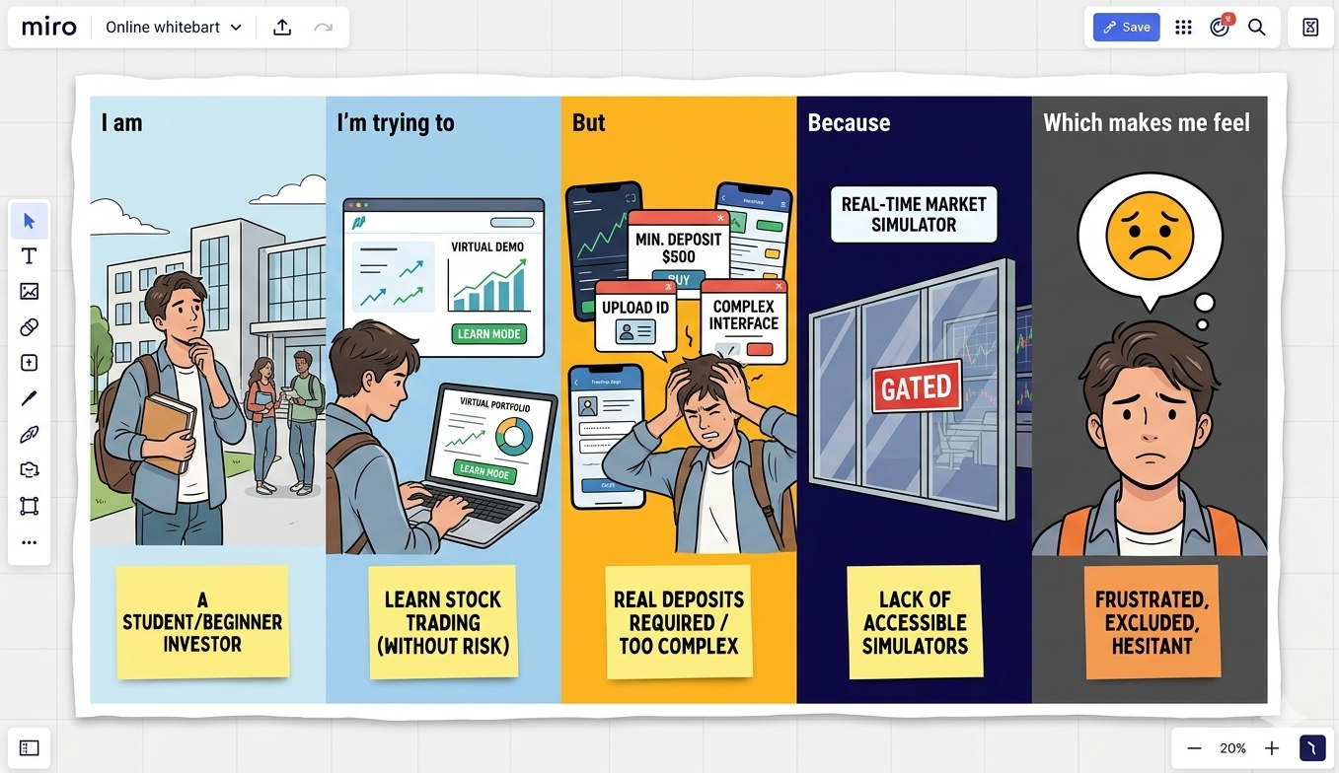
Reference: https://miro.com/templates/customer-problem-statement/

Example:
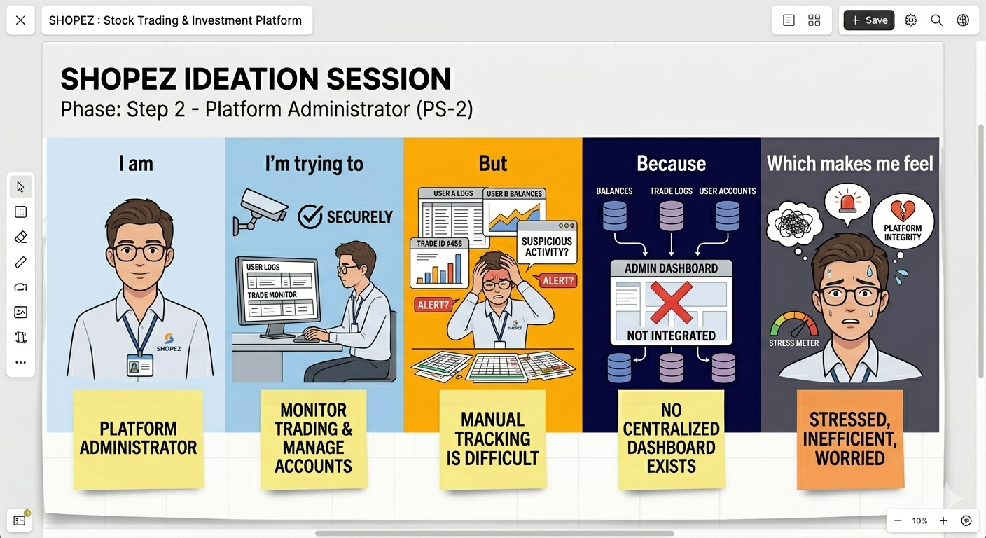

Problem Statement (PS) | I am (Customer) | I’m trying to | But | Because | Which makes me feel
PS-1 | A beginner investor / student | Learn how to trade stocks and build a portfolio without financial risk. | Existing trading applications require real money deposits or are too complex. | There is a lack of accessible, real-time market simulation platforms. | Overwhelmed, excluded, and hesitant to learn.
PS-2 | A platform administrator | Monitor trading activity and manage user accounts securely | Tracking virtual transactions and identifying suspicious activity manually is difficult. | There is no centralized dashboard aggregating user balances and trade logs. | Stressed, inefficient, and worried about platform integrity.

